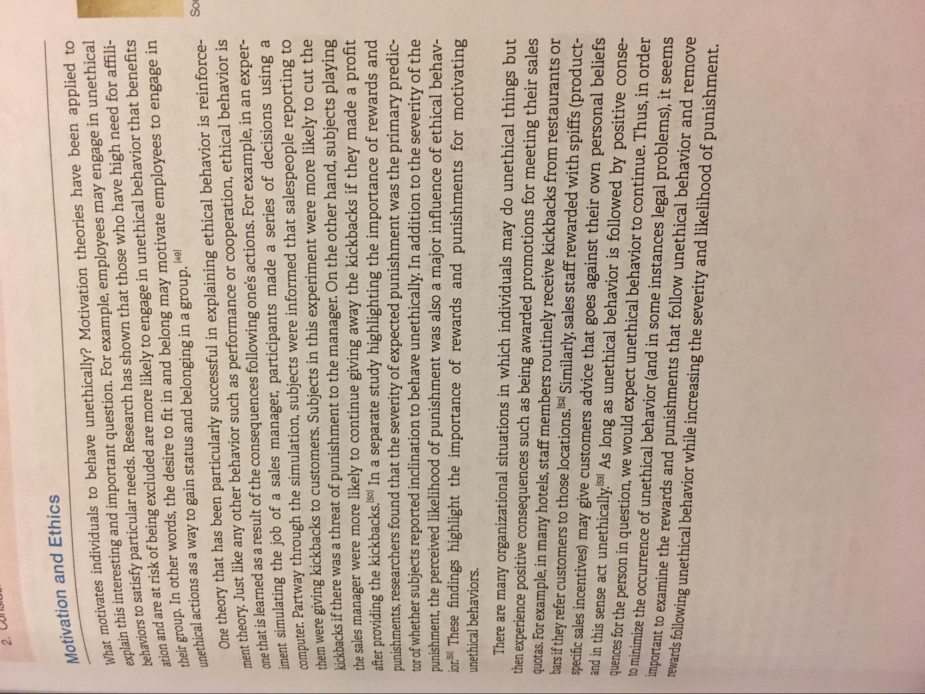
2. CONJU
Motivation and Ethics
SOL
at motivates individuals to behave unethically? Motivation theories have been applied to
ain this interesting and important question. For example, employees may engage in unethical ehaviors to satisfy particular needs. Research has shown that those who have high need for affiliion and are at risk of being excluded are more likely to engage in unethical behavior that benefits heir group. In other words, the desire to fit in and belong may motivate employees to engage in unethical actions as a way to gain status and belonging in a group. 149)
One theory that has been particularly successful in explaining ethical behavior is reinforcement theory. Just like any other behavior such as performance or cooperation, ethical behavior is one that is learned as a result of the consequences following one's actions. For example, in an experiment simulating the job of a sales manager, participants made a series of decisions using a computer. Partway through the simulation, subjects were informed that salespeople reporting to them were giving kickbacks to customers. Subjects in this experiment were more likely to cut the kickbacks if there was a threat of punishment to the manager. On the other hand, subjects playing the sales manager were more likely to continue giving away the kickbacks if they made a profit after providing the kickbacks.50) In a separate study highlighting the importance of rewards and punishments, researchers found that the severity of expected punishment was the primary predictor of whether subjects reported inclination to behave unethically. In addition to the severity of the punishment, the perceived likelihood of punishment was also a major influence of ethical behavior.51 These findings highlight the importance of rewards and punishments for motivating unethical behaviors.
There are many organizational situations in which individuals may do unethical things but then experience positive consequences such as being awarded promotions for meeting their sales quotas. For example, in many hotels, staff members routinely receive kickbacks from restaurants or bars if they refer customers to those locations.52 Similarly, sales staff rewarded with spiffs (productspecific sales incentives) may give customers advice that goes against their own personal beliefs and in this sense act unethically.53] As long as unethical behavior is followed by positive consequences for the person in question, we would expect unethical behavior to continue. Thus, in order to minimize the occurrence of unethical behavior (and in some instances legal problems), it seems important to examine the rewards and punishments that follow unethical behavior and remove rewards following unethical behavior while increasing the severity and likelihood of punishment.

